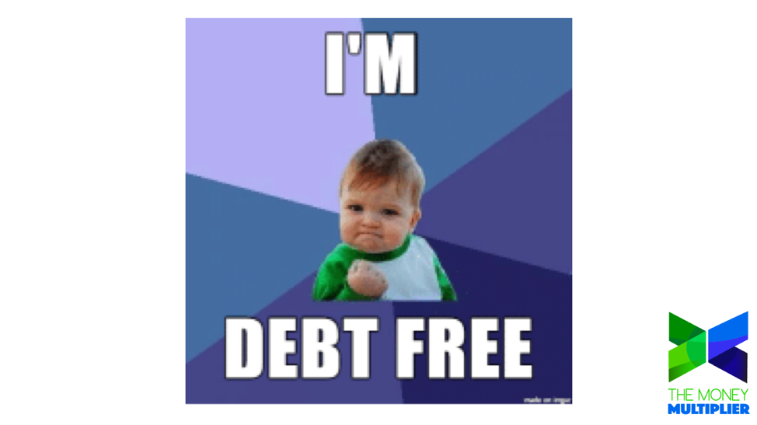
“I have no debt. Why do I need to take a loan?”
Remember, you’ve got to think like a banker. A banker looks at loans as assets, not liabilities. As consumers, loans take money out of their pocket. As a banker, loans put money in your pocket. You own the bank with The Money Multiplier. Taking loans against your policy will make you money! Think about this excerpt from pg. 48 of R. Nelson Nash’s “Becoming Your Own Banker” book. This comes from the foundational text book for what we do.
“It ways sounds a bit strange to people when I say, “premiums and income should match.” Let’s start with a very basic fact—doesn’t all your money go through someone else’s bank now? When you get your paycheck, what do you do with it? Right! You deposit it in someone else’s bank. Then you write checks against it to buy the things you want in life. While it is in the bank, the banker lends your money to someone else and makes a good living doing it!”
So, let’s answer that question that many of our members have after they begin the process of banking. “I don’t have debt, so why should I take a loan?” Read the quote above again and think about who the players are in the story. YOU get to be the banker.
It’s unrealistic to put our whole paycheck or income into our own bank right away, because we must capitalize first. Think about Brent Kesler’s education. Brent could not treat chiropractic patients his first year of chiropractic school. He had to spend time and energy to be capitalized first. Once Brent graduated from school (his full capitalization period), then he was ready to go to work and reap the full amount of benefits being a doctor could offer.
Once you’re banking system is capitalized, then you take loans to buy the things you are going to buy anyway (food, cars, houses, education,…). When you take a loan, you’re actually putting your policy up for collateral and borrowing from the general fund of the insurance company. Therefore, all your money is in your policy growing at the guaranteed interest rate. Your money is able to grow and be safe, while you are using loans to finance any expenses you have! How cool is this?
We all have expenses in our lives. Even without consumer debts like school loans, credit cards, or car notes, we have revolving “debts” from household utilities, groceries, gifts, and various memberships. When you have cash value and you take loans against your policy to cover even these mundane expenses in your life, you can grow the assets of your policy and you’ll have more money to use later.
Frequently Asked:
Will my cash value grow faster if I don’t take a loan? No. Your cash value has a guaranteed growth rate even when you take loans against your policy.

#MoreMoney
www.themoneymultiplier.com

